**MERN Assessment – Offer for Customers**

* Develop the MERN website as admin portal to configure offers for customers
* Create Buy X get Y form as shown in the screenshot

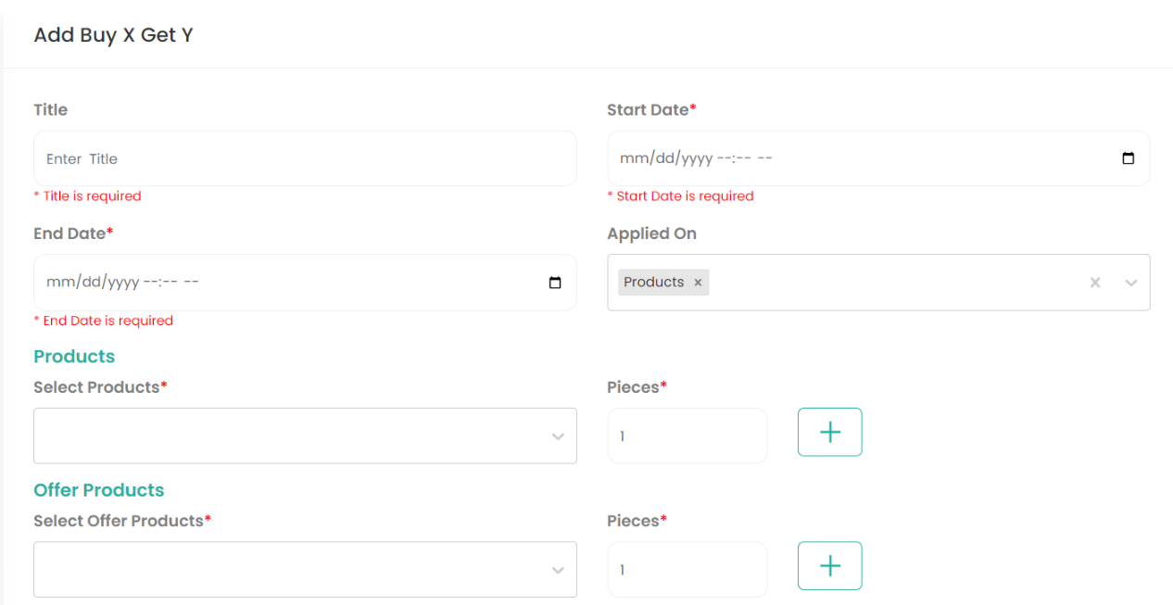

* Applied On: This field is a dropdown and should contain values as
  + Products
  + Brands
* Products: Rename this field to Products/Brands
* Consume product and brand JSON file sent along with this document and display in this field.
* Display only product names from JSON file if Products is selected in “Applied On” field otherwise display brand names from brand JSON file if Brands is selected in “Applied On” field
* Offer Products: This field should display all the product names from the product JSON file
* We should be able to perform all CRUD operations on Buy X get Y offers
* We should be able to download all Buy X get Y offers in excel
* Form should have validation and throw if we try to apply offer on the products/brands for which we already have the existing offer

*Example*: Buy 2 Pepsi Get 1 Coke Free

Buy 1 Oreo small pack Get 1 Oreo small pack Free